Newton’s Law of Gravity – Tyler Camp, for *Origin and Fate of the Universe*

12/17/2015

My name is Tyler, I am a senior game programming major, and I am a bit of a math geek. When I first saw Newton’s law of Universal Gravitation, I found it to be awesomely expressive and simple.

$$F_{g}=G\frac{m_{1}m_{2}}{r^{2}}$$

I had to see the effects of this equation for myself. I combined my current studies – data processing and simulation on the GPU, the powerhouse of modern games – with this desire to observe the system with my own eyes.

I created a program that runs interactively on my laptop – employing the GPU to run an N-body all-pairs simulation for 4000 celestial bodies with simple visual style. Since gravity is such a weak force, time has been scaled as much as 300 simulated years per second to allow us to see the effects of gravity in a meaningful way.

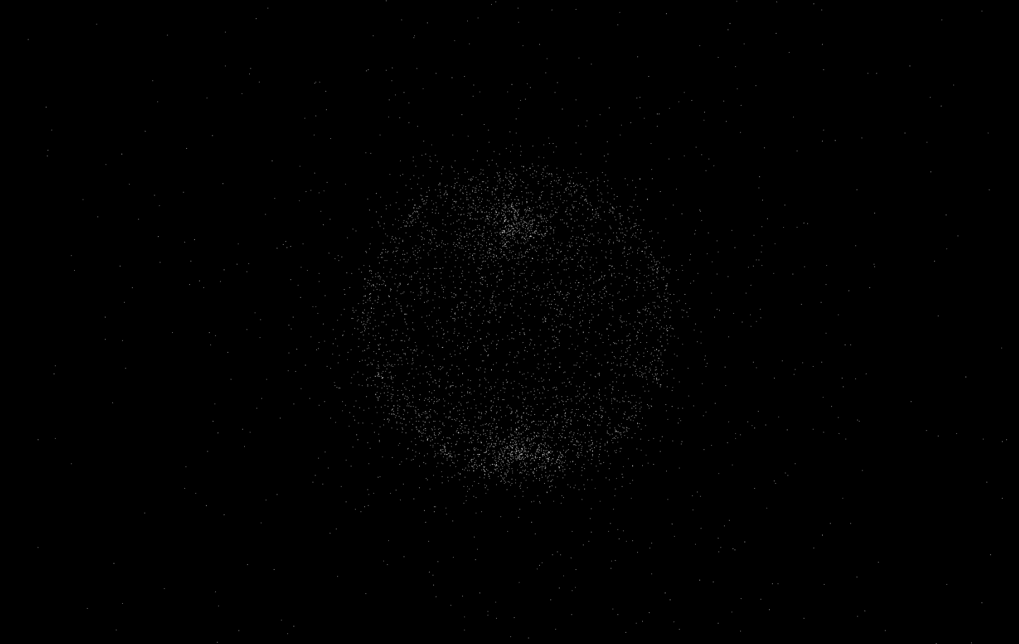

*Initial Simulation Setup*

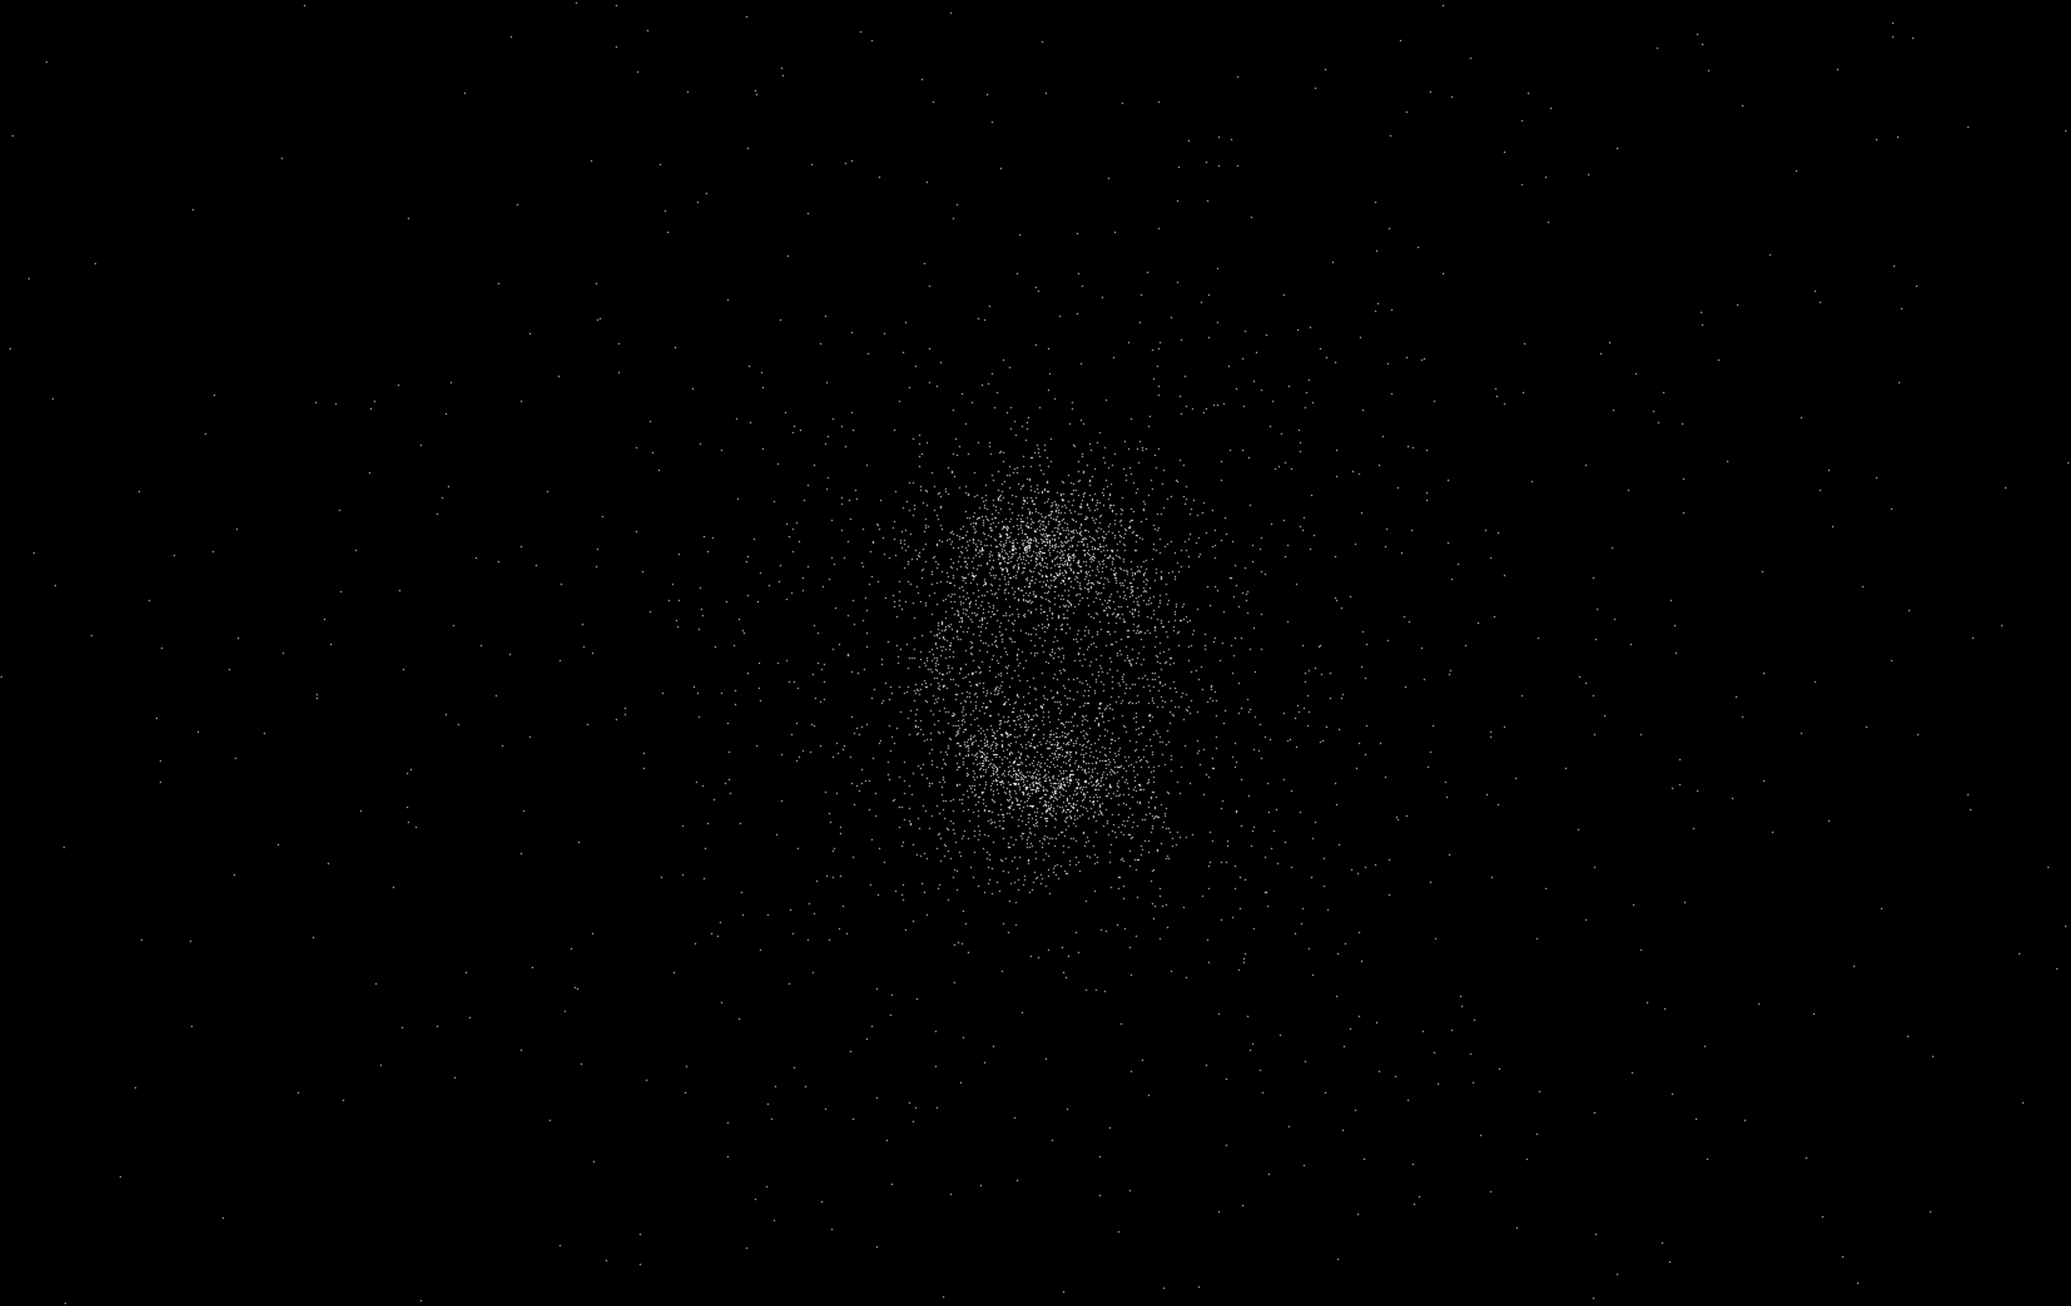

*The bodies making up the original sphere are collapsing towards center of gravity. Notice the abnormally high densities towards the top and bottom of the system – two large groups of bodies have been created (caused by inequal distribution of masses in the initial configuration – I use evenly-spaced spherical coordinates, which cause shifted distribution towards the poles)*

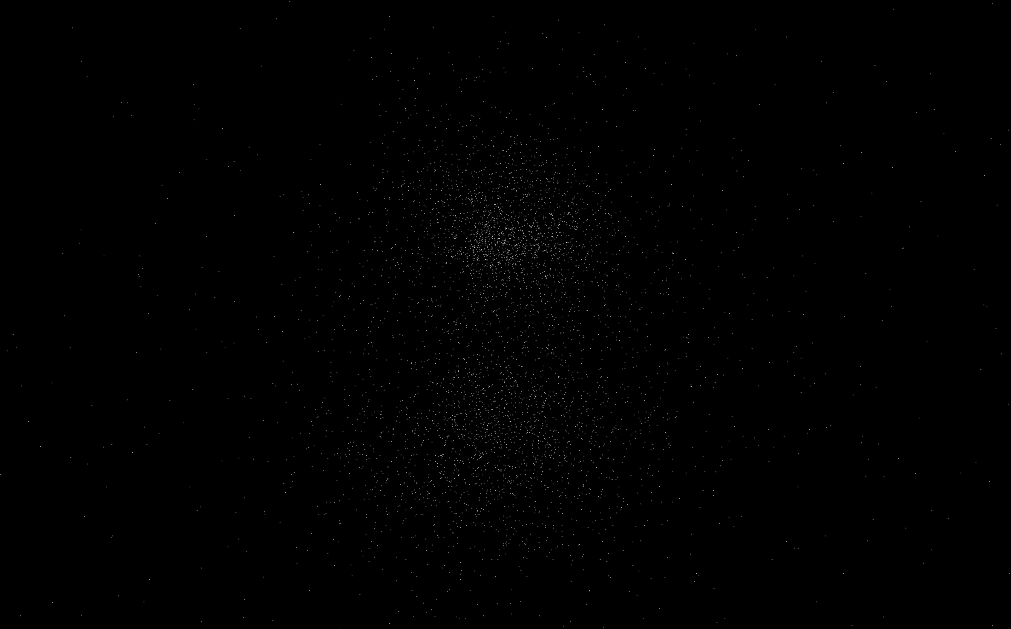

*The bodies pass through each other, but the original two large groups of bodies (top and bottom) stay intact and restabilize themselves*

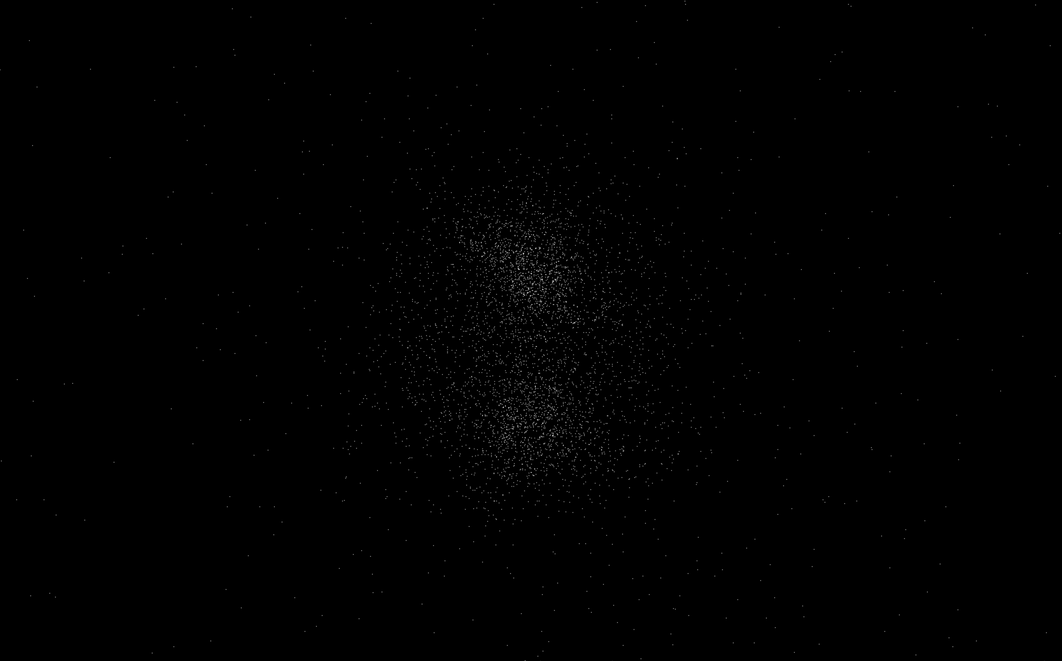

*Over time the two large groups of bodies gravitate towards each other, and form a single, high-velocity system of orbiting bodies.*

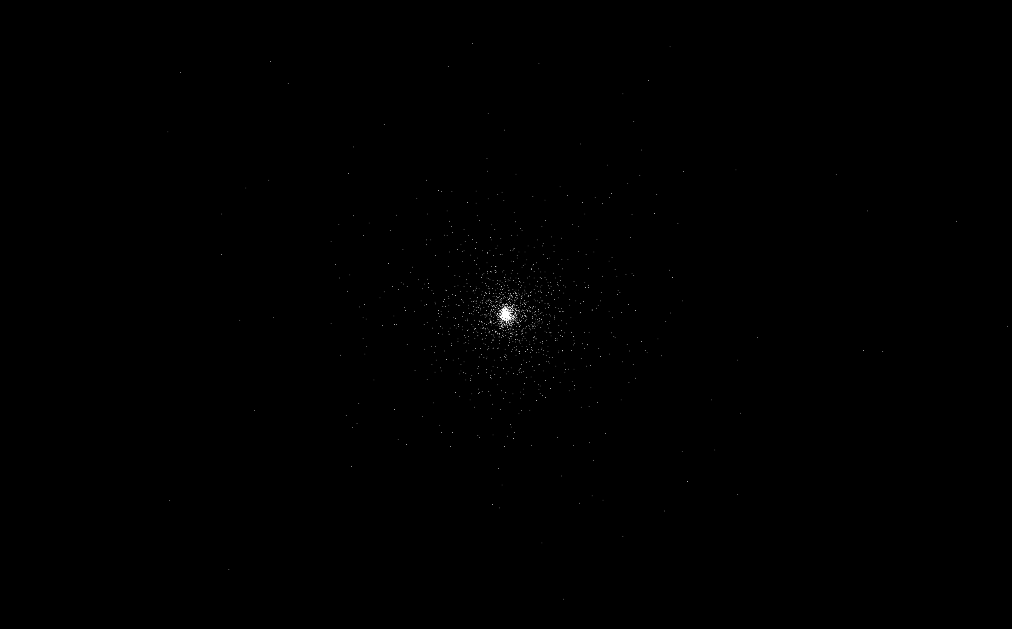

*Same system viewed at a distance of $1*{10}^{7}$ (Initial distance is ${10}^{5}$)*

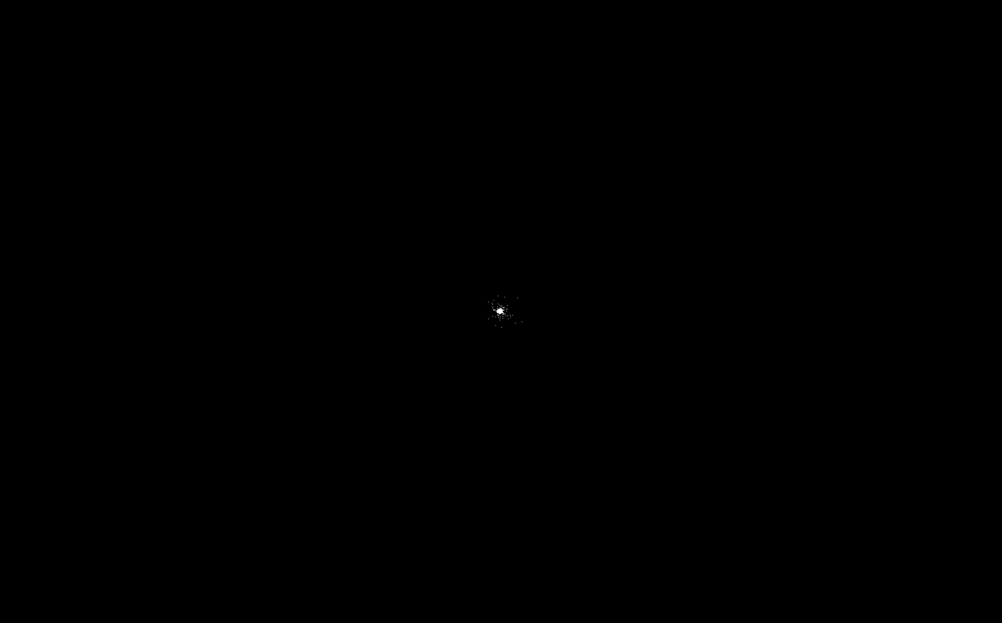

*Scaled at $1*{10}^{9}$, bodies can be seen at the very edges of the simulation area, which have been ejected out of the system due to orbiting too close to larger bodies. A similar method is used to take advantage of the gravity of planets in our solar system – probes are shot into space, on a course to interact with the gravity of a planet, which will accelerate the probe and enable it to travel further while conserving fuel.*

Finally, while this program is good at displaying the effects of large simulations, I found it lackluster as a simulator of stars. I created a second program, which uses the same simulation on a smaller scale, as well as various game graphics effects to create a more impressive display. Stars are colored by temperature, and temperature is directly calculated as a function of star mass.

